**INTRODUCTION TO GRAPHS**

* Graph is a non linear data structure; it contains a set of points known as nodes (or vertices) and set of links known as edges (or Arcs) which connects the vertices. A graph is defined as follows...
* Graph is a collection of vertices and arcs which connects vertices in the graph
* Graph is a collection of nodes and edges which connects nodes in the graph

Generally, a graph G is represented as G = (V, E), where V is set of vertices and E is set of edges.

Example

The following is a graph with 5 vertices and 6 edges.  
This graph G can be defined as G = ( V , E )  
Where V = {A,B,C,D,E} and E = {(A,B),(A,C)(A,D),(B,D),(C,D),(B,E),(E,D)}.

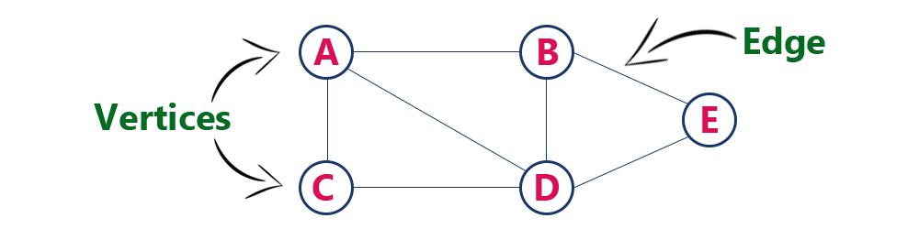

Graph Terminology

We use the following terms in graph data structure...

Vertex

A individual data element of a graph is called as Vertex. Vertex is also known as node. In above example graph, A, B, C, D & E are known as vertices.

Edge

An edge is a connecting link between two vertices. Edge is also known as Arc. An edge is represented as (starting Vertex, ending Vertex). For example, in above graph, the link between vertices A and B is represented as (A, B). In above example graph, there are 7 edges (i.e., (A,B), (A,C), (A,D), (B,D), (B,E), (C,D), (D,E)).  
  
Edges are three types.

Undirected Edge - An undirected edge is a bidirectional edge. If there is a undirected edge between vertices A and B then edge (A, B) is equal to edge (B, A).

Directed Edge - A directed edge is a unidirectional edge. If there is a directed edge between vertices A and B then edge (A, B) is not equal to edge (B, A).

Weighted Edge - A weighted edge is an edge with cost on it.

Undirected Graph

A graph with only undirected edges is said to be undirected graph.

Directed Graph

A graph with only directed edges is said to be directed graph.

Mixed Graph

A graph with undirected and directed edges is said to be mixed graph.

End vertices or Endpoints

The two vertices joined by an edge are called the end vertices (or endpoints) of the edge.

Origin

If an edge is directed, its first endpoint is said to be origin of it.

Destination

If an edge is directed, its first endpoint is said to be origin of it and the other endpoint is said to be the destination of the edge.

Adjacent

If there is an edge between vertices A and B then both A and B are said to be adjacent. In other words, Two vertices A and B are said to be adjacent if there is an edge whose end vertices are A and B.

Incident

An edge is said to be incident on a vertex if the vertex is one of the endpoints of that edge.

Outgoing Edge

A directed edge is said to be outgoing edge on its Origen vertex.

Incoming Edge

A directed edge is said to be incoming edge on its destination vertex.

Degree

Total number of edges connected to a vertex is said to be degree of that vertex.

In degree

Total number of incoming edges connected to a vertex is said to be indegree of that vertex.

Out degree

Total number of outgoing edges connected to a vertex is said to be outdegree of that vertex.

Parallel edges or multiple edges

If there are two undirected edges to have the same end vertices, and for two directed edges to have the same origin and the same destination. Such edges are called parallel edges or multiple edges.

Self-loop

An edge (undirected or directed) is a self-loop if its two endpoints coincide.

Simple Graph

A graph is said to be simple if there are no parallel and self-loop edges.

Path

A path is a sequence of alternating vertices and edges that starts at a vertex and ends at a vertex such that each edge is incident to its predecessor and successor vertex.

**Graph Representations:**

Graph data structure is represented using following representations...

* Adjacency Matrix
* Incidence Matrix
* Adjacency List

Adjacency Matrix

* In this representation, graph can be represented using a matrix of size total number of vertices by total number of vertices.
* That means if a graph with 4 vertices can be represented using a matrix of 4X4 class. In this matrix, rows and columns both represent vertices.
* This matrix is filled with either 1 or 0. Here, 1 represents there is an edge from row vertex to column vertex and 0 represents there is no edge from row vertex to column vertex.  
    
  For example, consider the following undirected graph representation...

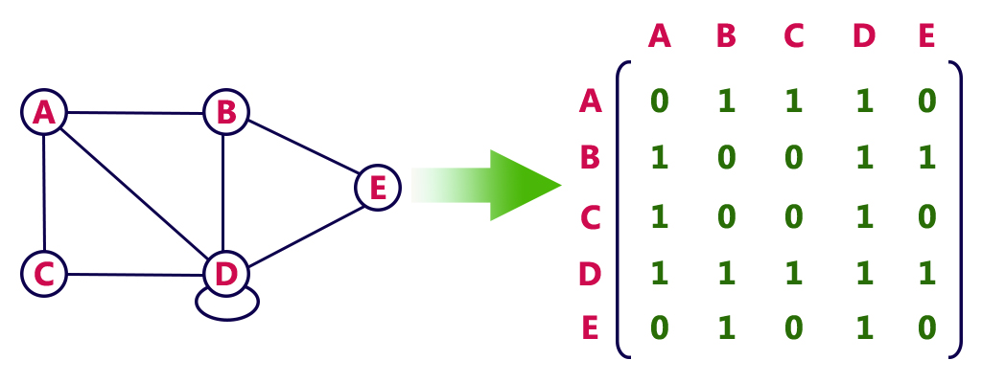

Directed graph representation...

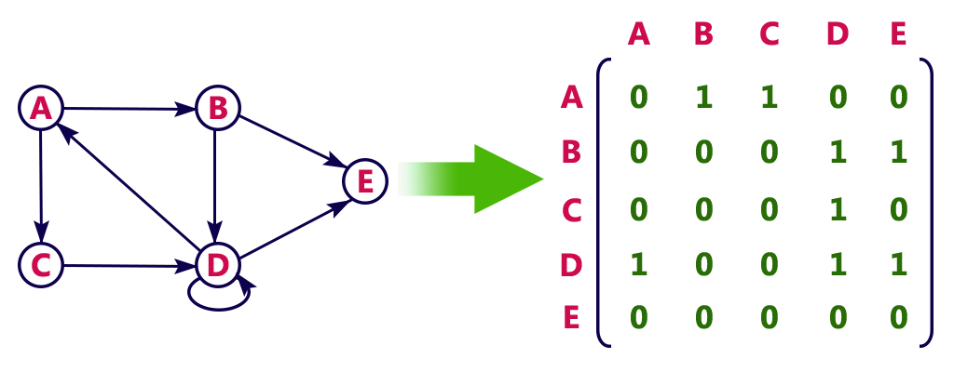

Incidence Matrix

* In this representation, graph can be represented using a matrix of size total number of vertices by total number of edges.
* That means if a graph with 4 vertices and 6 edges can be represented using a matrix of 4X6 class. In this matrix, rows represent vertices and columns represent edges.
* This matrix is filled with either 0 or 1 or -1.
* Here, 0 represents row edge is not connected to column vertex, 1 represents row edge is connected as outgoing edge to column vertex and -1 represents row edge is connected as incoming edge to column vertex.  
    
  For example, consider the following directed graph representation...

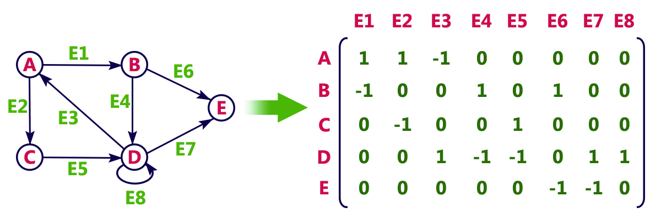

Adjacency List

In this representation, every vertex of graph contains list of its adjacent vertices.  
  
For example, consider the following directed graph representation implemented using linked list...

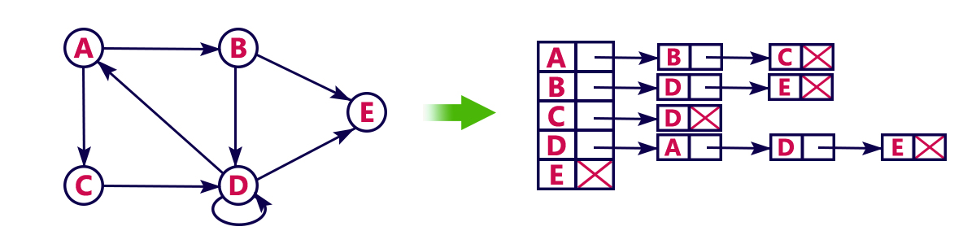

This representation can also be implemented using array as follows..

